**DBMS Project**

**Amazon warehouse database**

By Saish Pai

NUID :001222278

# DB Definition:

Warehouse is a large building where goods are stored before their distribution for sale. Finding a product in the warehouse is a challenge if the location is not known. A more interesting question is whether the product is available in sufficient quantities to cater to the demands of the customers. Tracking the product quantities and its location in the warehouse is necessary to create a smooth customer experience. The database will contain details about employees, suppliers, region, orders, products, logistics and transportation, inventory, categories, payments and shipments. This will enable us to resolve the critical issues mentioned earlier. Few key issues which will be resolved are as follows:

1 – Keeping a track of products

2 – Keeping a track of payments

3 – Manage shipments

4 – Help decide when to order which products

5 – Deciding if there is sufficient storage space

# EER MODEL

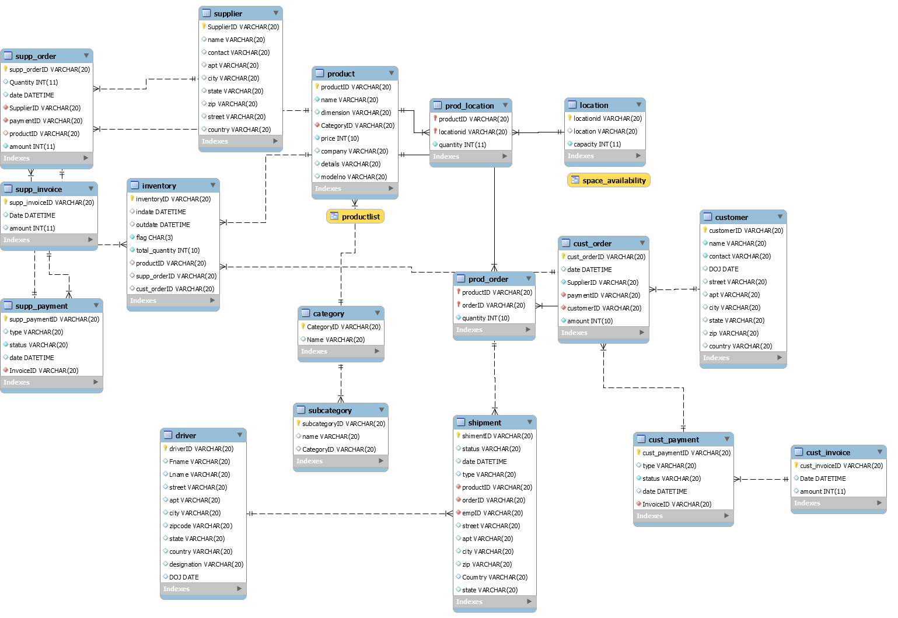



Basic entity relations:

* Products are stored at different locations.
* Multiple suppliers can supply the products.
* Customers order these products.
* Inventory contains the list of incoming and outgoing products.
* Products belongs to a category and a sub category.
* Customer orders are assigned to shipments

# Function:

**1 – The function “avail_space” is used to display the space available in a storage room**

CREATE DEFINER=`root`@`localhost` FUNCTION `avail_space`(lname varchar(20)) RETURNS int(11)

BEGIN

select sum(IFNULL(l.capacity,0)-(IFNULL(p.dimension,0)*IFNULL(pl.quantity,0))) into @avail_space from Location as l

join prod_location as pl on (l.locationid = pl.locationid)

join product as p on (pl.productid = p.productid)

where l.location = lname

group by pl.locationid;

RETURN @avail_space ;

END

Output:

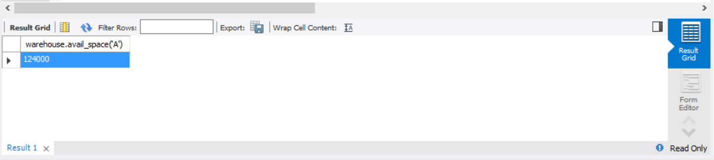

The space available have been calculated in cubic centimeters, and therefore every product has a dimension or volume attached to it.

**2- The function “prod_location” lets us enter the product name and finds its location in the warehouse**

CREATE DEFINER=`root`@`localhost` FUNCTION `product_location`(pname varchar(20)) RETURNS varchar(20) CHARSET utf8

BEGIN

declare result varchar(20);

set result = "Z";

select l.location INTO result

from location as l

join prod_location as pl on (pl.locationid = l.locationid)

join product as p on (p.productID = pl.productID)

where p.name = pname;

RETURN result;

END

Output:

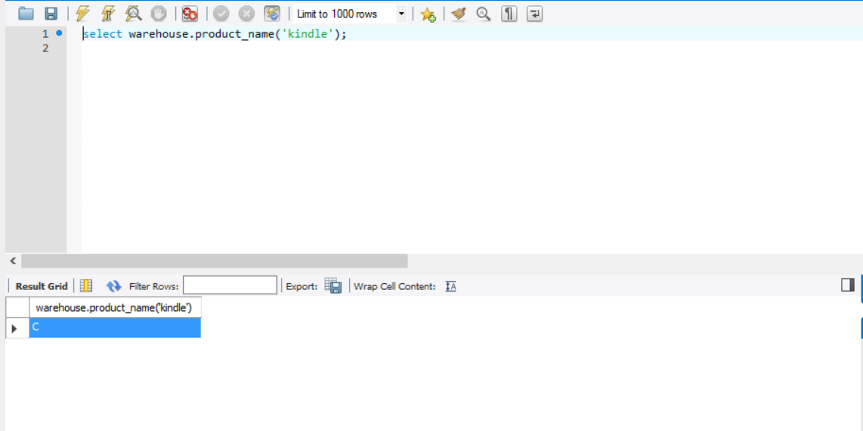

**3- The function “avail_quantity” lets you input a product name and returns back the in-stock quantity.**

DELIMITER $$

CREATE DEFINER=`root`@`localhost` FUNCTION `avail_quantity`(pname varchar(20)) RETURNS int(11)

BEGIN

declare totalin integer;

declare totalout integer;

SELECT

SUM(total_quantity)

INTO @totalin FROM

warehouse.inventory as i

join product as p on p.productID = i.productID

WHERE

p.name = pname

AND flag = 'in';

SELECT

SUM(total_quantity)

INTO @totalout FROM

warehouse.inventory as i

join product as p on p.productID = i.productID

WHERE

p.name = pname

AND flag = 'out'

Return @totalin - @totalout;

END$$

DELIMITER ;

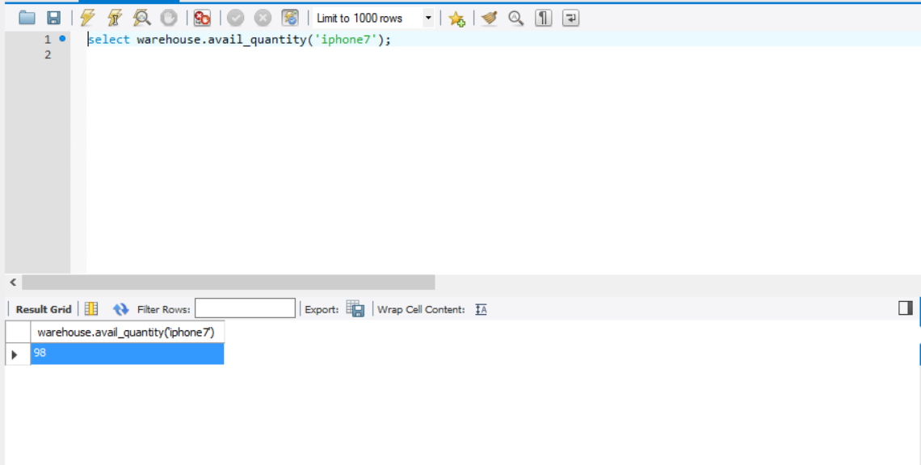

Views:

**1 – The “product”list view lets the user to check all the products available in the warehouse with its price and available quantity. I have used the avail_quantity function in this view.**

CREATE

ALGORITHM = UNDEFINED

DEFINER = `root`@`localhost`

SQL SECURITY DEFINER

VIEW `warehouse`.`productlist` AS

SELECT

`p`.`productID` AS `productID`,

`p`.`name` AS `name`,

`p`.`price` AS `price`,

AVAIL_QUANTITY(`p`.`name`) AS `available_quantity`

FROM

`warehouse`.`product` `p`

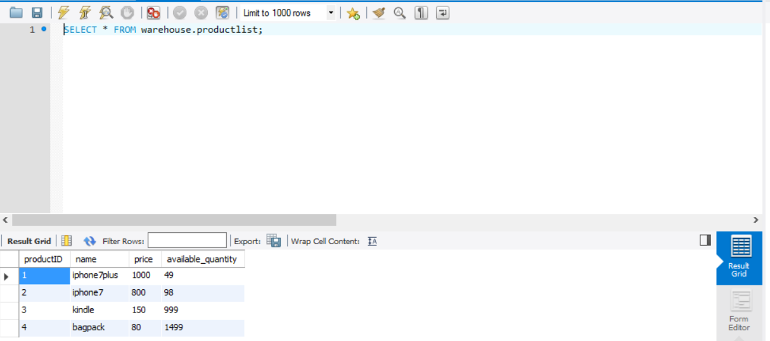

This is an important view as it will help decide which product must be ordered

**2 – The space availability view provides a list of all the rooms and the space available in them**

CREATE

ALGORITHM = UNDEFINED

DEFINER = `root`@`localhost`

SQL SECURITY DEFINER

VIEW `warehouse`.`space_availability` AS

SELECT

`l`.`location` AS `location`,

`l`.`locationid` AS `locationid`,

AVAIL_SPACE(`l`.`location`) AS `space_available`

FROM

`warehouse`.`location` `l`

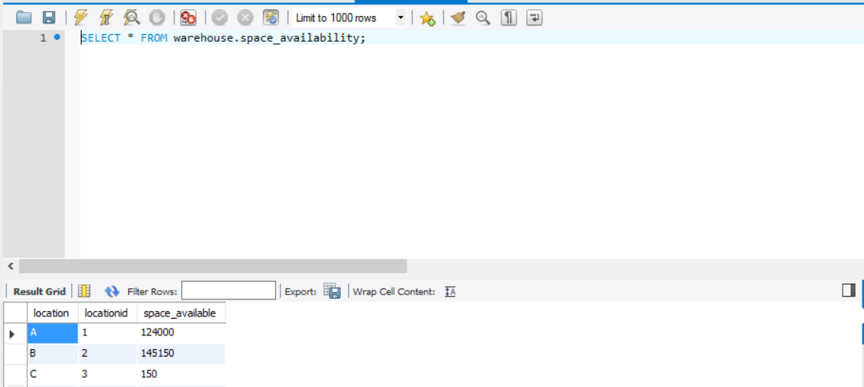

**As seen above it provides the storage space available at every location.**

Stored Procedure:

**1 – The “get_custpayment_status” provides us the product details and its payment status by entering the customer name**

CREATE DEFINER=`root`@`localhost` PROCEDURE `get_custpayment_status`(IN customer_name VARCHAR(255))

BEGIN

select c.name as Customer_Name, p.name as Product_Name, cp.status as payment_status

from customer c,

cust_order co,

prod_order po,

product p,

cust_payment cp

where c.customerID = co.customerID

and co.cust_orderID = po.orderID

and p.productID = po.productID

and cp.cust_paymentID = co.paymentID

and c.name = customer_name;

END

**Output-**

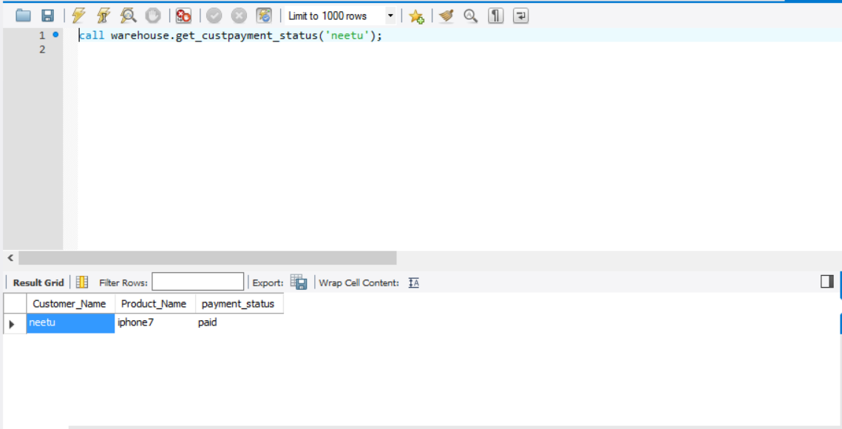

**2 - The “get_supply_payment_status” provides us the order date and its payment status by entering the supplier name**

CREATE DEFINER=`root`@`localhost` PROCEDURE `get_supply_payment_status`(IN supplier_name VARCHAR(255))

BEGIN

select s.name as Supplier_name, so.date as Order_Date, sp.status as Payment_Status

from supplier s,

supp_order so,

supp_payment sp

where s.SupplierID = so.SupplierID

and so.paymentID = sp.supp_paymentID

and s.name = supplier_name;

END

**Output-**

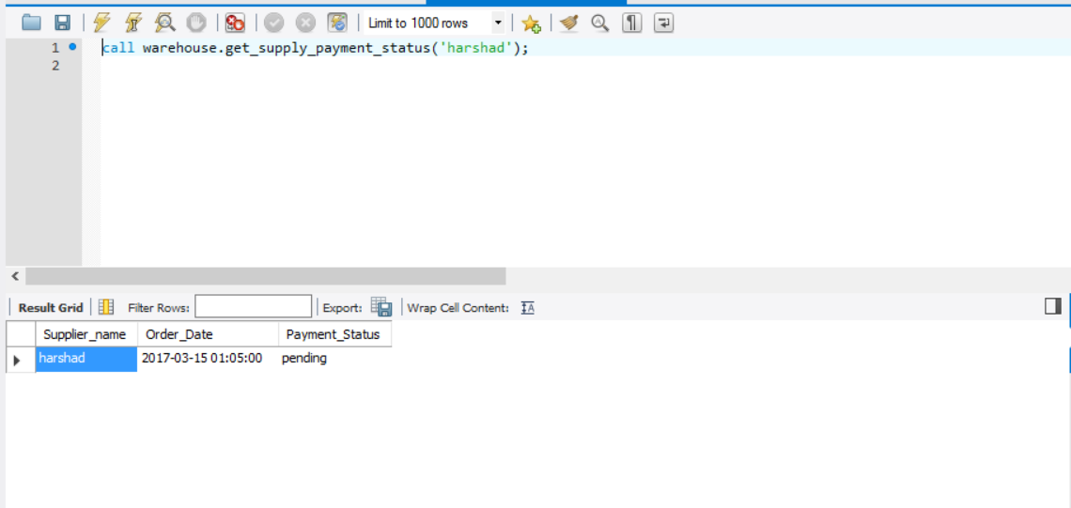

**3 - The “get_order_status” provides us with the delivery status for all the products that have been ordered by the customer.**

CREATE DEFINER=`root`@`localhost` PROCEDURE `getorder_status`(IN customer_name VARCHAR(255))

BEGIN

select c.name as Customer_Name,p.name as Product_Name, s.status as Delivery_Status

from customer c,

cust_order co,

prod_order po,

shipment s,

product p

where c.customerID = co.customerID

and co.cust_orderID = po.orderID

and po.productID = s.productID

and po.orderID = s.orderID

and p.productID = po.productID

and c.name = customer_name;

END

**Output-**

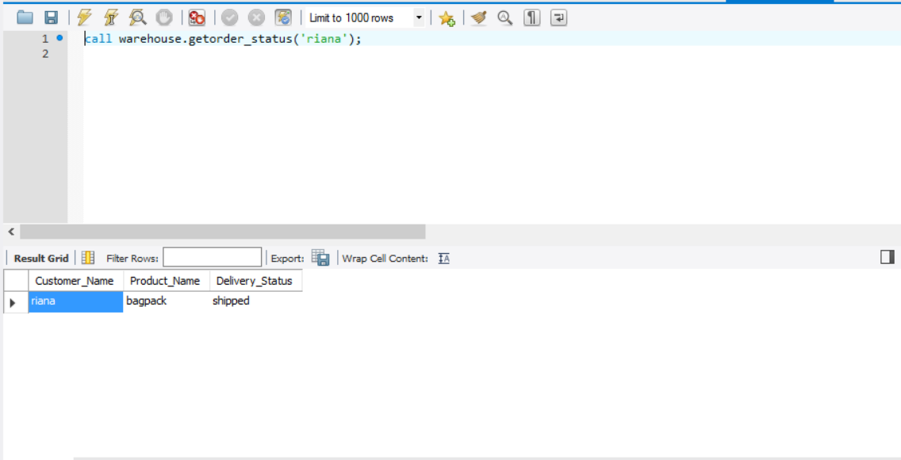

**4- The “get_product_location” helps us to find out at what all positions do we have the products stored.**

CREATE DEFINER=`root`@`localhost` PROCEDURE `get_product_location`(pname varchar(20))

BEGIN

select p.name, l.location

from location as l

join prod_location as pl on (pl.locationid = l.locationid)

join product as p on (p.productID = pl.productID)

where p.name = pname;

END

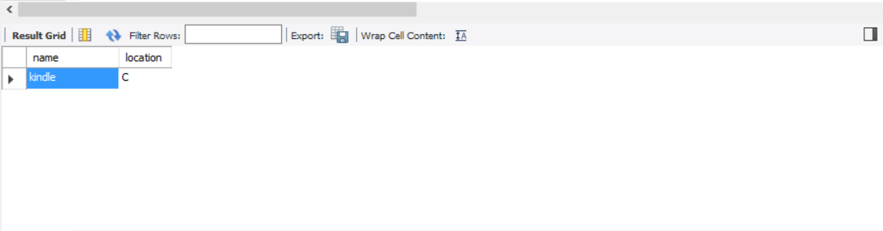

Further improvements

1. Currently only the warehouse manager has the access to the database, with further expansion the database must add different users with varying privileges.
2. Keeping a track of a unique identifying number for every product should be included.
3. Space unavailability alerts should be configured.
4. Demand for a particular products can be calculated and automatic ordering can be scheduled.

Final project code-

-- MySQL dump 10.13 Distrib 5.7.12, for Win64 (x86_64)

--

-- Host: localhost Database: warehouse

-- ------------------------------------------------------

-- Server version 5.7.17-log

/*!40101 SET @OLD_CHARACTER_SET_CLIENT=@@CHARACTER_SET_CLIENT */;

/*!40101 SET @OLD_CHARACTER_SET_RESULTS=@@CHARACTER_SET_RESULTS */;

/*!40101 SET @OLD_COLLATION_CONNECTION=@@COLLATION_CONNECTION */;

/*!40101 SET NAMES utf8 */;

/*!40103 SET @OLD_TIME_ZONE=@@TIME_ZONE */;

/*!40103 SET TIME_ZONE='+00:00' */;

/*!40014 SET @OLD_UNIQUE_CHECKS=@@UNIQUE_CHECKS, UNIQUE_CHECKS=0 */;

/*!40014 SET @OLD_FOREIGN_KEY_CHECKS=@@FOREIGN_KEY_CHECKS, FOREIGN_KEY_CHECKS=0 */;

/*!40101 SET @OLD_SQL_MODE=@@SQL_MODE, SQL_MODE='NO_AUTO_VALUE_ON_ZERO' */;

/*!40111 SET @OLD_SQL_NOTES=@@SQL_NOTES, SQL_NOTES=0 */;

--

-- Table structure for table `category`

--

DROP TABLE IF EXISTS `category`;

/*!40101 SET @saved_cs_client = @@character_set_client */;

/*!40101 SET character_set_client = utf8 */;

CREATE TABLE `category` (

`CategoryID` varchar(20) NOT NULL,

`Name` varchar(20) DEFAULT NULL,

PRIMARY KEY (`CategoryID`),

UNIQUE KEY `CategoryID` (`CategoryID`)

) ENGINE=InnoDB DEFAULT CHARSET=utf8;

/*!40101 SET character_set_client = @saved_cs_client */;

--

-- Dumping data for table `category`

--

LOCK TABLES `category` WRITE;

/*!40000 ALTER TABLE `category` DISABLE KEYS */;

INSERT INTO `category` VALUES ('1','electronics'),('2','accesories'),('3','luggage'),('4','stationary');

/*!40000 ALTER TABLE `category` ENABLE KEYS */;

UNLOCK TABLES;

--

-- Table structure for table `cust_invoice`

--

DROP TABLE IF EXISTS `cust_invoice`;

/*!40101 SET @saved_cs_client = @@character_set_client */;

/*!40101 SET character_set_client = utf8 */;

CREATE TABLE `cust_invoice` (

`cust_invoiceID` varchar(20) NOT NULL,

`Date` datetime DEFAULT NULL,

`amount` int(11) DEFAULT NULL,

PRIMARY KEY (`cust_invoiceID`),

UNIQUE KEY `InvoiceID` (`cust_invoiceID`)

) ENGINE=InnoDB DEFAULT CHARSET=utf8;

/*!40101 SET character_set_client = @saved_cs_client */;

--

-- Dumping data for table `cust_invoice`

--

LOCK TABLES `cust_invoice` WRITE;

/*!40000 ALTER TABLE `cust_invoice` DISABLE KEYS */;

INSERT INTO `cust_invoice` VALUES ('145','2017-04-20 10:05:00',800),('2547','2017-04-17 01:05:00',1000),('3599','2017-04-18 02:05:00',1600),('71201','2017-04-19 01:55:00',80),('7845','2017-04-20 10:05:00',150);

/*!40000 ALTER TABLE `cust_invoice` ENABLE KEYS */;

UNLOCK TABLES;

--

-- Table structure for table `cust_order`

--

DROP TABLE IF EXISTS `cust_order`;

/*!40101 SET @saved_cs_client = @@character_set_client */;

/*!40101 SET character_set_client = utf8 */;

CREATE TABLE `cust_order` (

`cust_orderID` varchar(20) NOT NULL,

`date` datetime DEFAULT NULL,

`SupplierID` varchar(20) NOT NULL,

`paymentID` varchar(20) NOT NULL,

`customerID` varchar(20) NOT NULL,

`amount` int(10) unsigned NOT NULL,

PRIMARY KEY (`cust_orderID`),

UNIQUE KEY `orderID` (`cust_orderID`),

KEY `IX_Relationship2` (`SupplierID`),

KEY `IX_Relationship7` (`paymentID`),

KEY `IX_Relationship11` (`customerID`),

CONSTRAINT `Relationship11` FOREIGN KEY (`customerID`) REFERENCES `customer` (`customerID`),

CONSTRAINT `Relationship9` FOREIGN KEY (`paymentID`) REFERENCES `cust_payment` (`cust_paymentID`)

) ENGINE=InnoDB DEFAULT CHARSET=utf8;

/*!40101 SET character_set_client = @saved_cs_client */;

--

-- Dumping data for table `cust_order`

--

LOCK TABLES `cust_order` WRITE;

/*!40000 ALTER TABLE `cust_order` DISABLE KEYS */;

INSERT INTO `cust_order` VALUES ('1','2017-04-17 01:04:00','1','1','1',1000),('2','2017-04-18 02:03:00','2','2','2',1600),('3','2017-04-19 01:53:00','3','3','3',80),('4','2017-04-20 10:05:00','4','4','4',150),('5','2017-04-20 10:05:00','4','5','1',150);

/*!40000 ALTER TABLE `cust_order` ENABLE KEYS */;

UNLOCK TABLES;

--

-- Table structure for table `cust_payment`

--

DROP TABLE IF EXISTS `cust_payment`;

/*!40101 SET @saved_cs_client = @@character_set_client */;

/*!40101 SET character_set_client = utf8 */;

CREATE TABLE `cust_payment` (

`cust_paymentID` varchar(20) NOT NULL,

`type` varchar(20) DEFAULT NULL,

`status` varchar(20) NOT NULL,

`date` datetime DEFAULT NULL,

`InvoiceID` varchar(20) NOT NULL,

PRIMARY KEY (`cust_paymentID`),

UNIQUE KEY `paymentID` (`cust_paymentID`),

KEY `IX_Relationship8` (`InvoiceID`),

CONSTRAINT `Relationship10` FOREIGN KEY (`InvoiceID`) REFERENCES `cust_invoice` (`cust_invoiceID`)

) ENGINE=InnoDB DEFAULT CHARSET=utf8;

/*!40101 SET character_set_client = @saved_cs_client */;

--

-- Dumping data for table `cust_payment`

--

LOCK TABLES `cust_payment` WRITE;

/*!40000 ALTER TABLE `cust_payment` DISABLE KEYS */;

INSERT INTO `cust_payment` VALUES ('1','online','paid','2017-04-17 01:04:00','2547'),('2','online','paid','2017-04-18 02:03:00','3599'),('3','online','paid','2017-04-19 01:53:00','71201'),('4','online','paid','2017-04-20 10:05:00','7845'),('5','online','paid','2017-04-20 10:05:00','145');

/*!40000 ALTER TABLE `cust_payment` ENABLE KEYS */;

UNLOCK TABLES;

--

-- Table structure for table `customer`

--

DROP TABLE IF EXISTS `customer`;

/*!40101 SET @saved_cs_client = @@character_set_client */;

/*!40101 SET character_set_client = utf8 */;

CREATE TABLE `customer` (

`customerID` varchar(20) NOT NULL,

`name` varchar(20) NOT NULL,

`contact` varchar(20) NOT NULL,

`DOJ` date DEFAULT NULL,

`street` varchar(20) DEFAULT NULL,

`apt` varchar(20) DEFAULT NULL,

`city` varchar(20) DEFAULT NULL,

`state` varchar(20) DEFAULT NULL,

`zip` varchar(20) DEFAULT NULL,

`country` varchar(20) DEFAULT NULL,

PRIMARY KEY (`customerID`),

UNIQUE KEY `customerID` (`customerID`)

) ENGINE=InnoDB DEFAULT CHARSET=utf8;

/*!40101 SET character_set_client = @saved_cs_client */;

--

-- Dumping data for table `customer`

--

LOCK TABLES `customer` WRITE;

/*!40000 ALTER TABLE `customer` DISABLE KEYS */;

INSERT INTO `customer` VALUES ('1','sristhi','2145789687','2014-07-12','bloyston','25','boston','MA','02215','USA'),('2','neetu','2145783698','2013-07-12','abc','15','boston','MA','02215','USA'),('3','riana','5427863210','2015-08-12','ert','45','quincy','MA','02217','USA'),('4','raghu','5875146310','2016-07-12','hi','17','hoboken','NJ','12554','USA'),('5','yuvraj','7846302159','2014-07-18','seeyou','67','newyork','NY','87542','USA');

/*!40000 ALTER TABLE `customer` ENABLE KEYS */;

UNLOCK TABLES;

--

-- Table structure for table `driver`

--

DROP TABLE IF EXISTS `driver`;

/*!40101 SET @saved_cs_client = @@character_set_client */;

/*!40101 SET character_set_client = utf8 */;

CREATE TABLE `driver` (

`driverID` varchar(20) NOT NULL,

`Fname` varchar(20) DEFAULT NULL,

`Lname` varchar(20) DEFAULT NULL,

`street` varchar(20) DEFAULT NULL,

`apt` varchar(20) DEFAULT NULL,

`city` varchar(20) DEFAULT NULL,

`zipcode` varchar(20) DEFAULT NULL,

`state` varchar(20) DEFAULT NULL,

`country` varchar(20) DEFAULT NULL,

`designation` varchar(20) DEFAULT NULL,

`DOJ` date DEFAULT NULL,

PRIMARY KEY (`driverID`),

UNIQUE KEY `empID` (`driverID`)

) ENGINE=InnoDB DEFAULT CHARSET=utf8;

/*!40101 SET character_set_client = @saved_cs_client */;

--

-- Dumping data for table `driver`

--

LOCK TABLES `driver` WRITE;

/*!40000 ALTER TABLE `driver` DISABLE KEYS */;

INSERT INTO `driver` VALUES ('1','jb','bill','abm','74','boston','02178','MA','USA','asst.Driver','2010-02-19'),('2','smith','williams','parkdrive','1165','boston','32214','MA',NULL,'driver','2010-04-15'),('3','craig','lee','tremont','78','waltham','08756','MA',NULL,'supervisor','2009-02-21');

/*!40000 ALTER TABLE `driver` ENABLE KEYS */;

UNLOCK TABLES;

--

-- Table structure for table `inventory`

--

DROP TABLE IF EXISTS `inventory`;

/*!40101 SET @saved_cs_client = @@character_set_client */;

/*!40101 SET character_set_client = utf8 */;

CREATE TABLE `inventory` (

`inventoryID` varchar(20) NOT NULL,

`indate` datetime DEFAULT NULL,

`outdate` datetime DEFAULT NULL,

`flag` char(3) NOT NULL,

`total_quantity` int(10) unsigned NOT NULL,

`productID` varchar(20) DEFAULT NULL,

`supp_orderID` varchar(20) DEFAULT NULL,

`cust_orderID` varchar(20) DEFAULT NULL,

PRIMARY KEY (`inventoryID`),

UNIQUE KEY `InvtID` (`inventoryID`),

KEY `IX_Relationship22` (`productID`),

KEY `IX_Relationship24` (`supp_orderID`),

KEY `cust_orderID` (`cust_orderID`),

CONSTRAINT `Relationship22` FOREIGN KEY (`productID`) REFERENCES `product` (`productID`),

CONSTRAINT `Relationship24` FOREIGN KEY (`supp_orderID`) REFERENCES `supp_order` (`supp_orderID`),

CONSTRAINT `inventory_ibfk_1` FOREIGN KEY (`cust_orderID`) REFERENCES `cust_order` (`cust_orderID`)

) ENGINE=InnoDB DEFAULT CHARSET=utf8;

/*!40101 SET character_set_client = @saved_cs_client */;

--

-- Dumping data for table `inventory`

--

LOCK TABLES `inventory` WRITE;

/*!40000 ALTER TABLE `inventory` DISABLE KEYS */;

INSERT INTO `inventory` VALUES ('1',NULL,'2017-04-17 01:04:00','out',1,'1',NULL,'1'),('2',NULL,'2017-04-18 02:03:00','out',2,'2',NULL,'2'),('3',NULL,'2017-04-19 01:53:00','out',1,'4',NULL,'3'),('4',NULL,'2017-04-20 10:05:00','out',1,'3',NULL,'4'),('5','2017-03-15 01:05:00',NULL,'in',50,'1','1',NULL),('6','2017-03-15 01:05:00',NULL,'in',100,'2','2',NULL),('7','2017-03-15 01:05:00',NULL,'in',1000,'3','3',NULL),('8','2017-03-15 01:05:00',NULL,'in',1500,'4','4',NULL);

/*!40000 ALTER TABLE `inventory` ENABLE KEYS */;

UNLOCK TABLES;

--

-- Table structure for table `location`

--

DROP TABLE IF EXISTS `location`;

/*!40101 SET @saved_cs_client = @@character_set_client */;

/*!40101 SET character_set_client = utf8 */;

CREATE TABLE `location` (

`locationid` varchar(20) NOT NULL,

`location` varchar(20) DEFAULT NULL,

`capacity` int(11) NOT NULL,

PRIMARY KEY (`locationid`),

UNIQUE KEY `locationid` (`locationid`)

) ENGINE=InnoDB DEFAULT CHARSET=utf8;

/*!40101 SET character_set_client = @saved_cs_client */;

--

-- Dumping data for table `location`

--

LOCK TABLES `location` WRITE;

/*!40000 ALTER TABLE `location` DISABLE KEYS */;

INSERT INTO `location` VALUES ('1','A',150000),('2','B',100000),('3','C',150000),('4','D',75000),('5','E',125000);

/*!40000 ALTER TABLE `location` ENABLE KEYS */;

UNLOCK TABLES;

--

-- Table structure for table `prod_location`

--

DROP TABLE IF EXISTS `prod_location`;

/*!40101 SET @saved_cs_client = @@character_set_client */;

/*!40101 SET character_set_client = utf8 */;

CREATE TABLE `prod_location` (

`productID` varchar(20) NOT NULL,

`locationid` varchar(20) NOT NULL,

`quantity` int(11) NOT NULL,

PRIMARY KEY (`productID`,`locationid`),

KEY `Relationship29` (`locationid`),

CONSTRAINT `Relationship28` FOREIGN KEY (`productID`) REFERENCES `product` (`productID`),

CONSTRAINT `Relationship29` FOREIGN KEY (`locationid`) REFERENCES `location` (`locationid`)

) ENGINE=InnoDB DEFAULT CHARSET=utf8;

/*!40101 SET character_set_client = @saved_cs_client */;

--

-- Dumping data for table `prod_location`

--

LOCK TABLES `prod_location` WRITE;

/*!40000 ALTER TABLE `prod_location` DISABLE KEYS */;

INSERT INTO `prod_location` VALUES ('1','1',40),('1','2',9),('2','2',98),('3','3',999);

/*!40000 ALTER TABLE `prod_location` ENABLE KEYS */;

UNLOCK TABLES;

--

-- Table structure for table `prod_order`

--

DROP TABLE IF EXISTS `prod_order`;

/*!40101 SET @saved_cs_client = @@character_set_client */;

/*!40101 SET character_set_client = utf8 */;

CREATE TABLE `prod_order` (

`productID` varchar(20) NOT NULL,

`cust_orderID` varchar(20) NOT NULL,

`quantity` int(10) unsigned NOT NULL,

PRIMARY KEY (`productID`,`cust_orderID`),

KEY `Relationship13` (`cust_orderID`),

CONSTRAINT `Relationship12` FOREIGN KEY (`productID`) REFERENCES `product` (`productID`),

CONSTRAINT `Relationship13` FOREIGN KEY (`cust_orderID`) REFERENCES `cust_order` (`cust_orderID`)

) ENGINE=InnoDB DEFAULT CHARSET=utf8;

/*!40101 SET character_set_client = @saved_cs_client */;

--

-- Dumping data for table `prod_order`

--

LOCK TABLES `prod_order` WRITE;

/*!40000 ALTER TABLE `prod_order` DISABLE KEYS */;

INSERT INTO `prod_order` VALUES ('1','1',1),('2','2',2),('3','1',2),('3','4',1),('4','3',1);

/*!40000 ALTER TABLE `prod_order` ENABLE KEYS */;

UNLOCK TABLES;

--

-- Table structure for table `product`

--

DROP TABLE IF EXISTS `product`;

/*!40101 SET @saved_cs_client = @@character_set_client */;

/*!40101 SET character_set_client = utf8 */;

CREATE TABLE `product` (

`productID` varchar(20) NOT NULL,

`name` varchar(20) NOT NULL,

`dimension` varchar(20) DEFAULT NULL,

`CategoryID` varchar(20) NOT NULL,

`price` int(10) unsigned NOT NULL,

`company` varchar(20) DEFAULT NULL,

`details` varchar(20) DEFAULT NULL,

`modelno` varchar(20) DEFAULT NULL,

PRIMARY KEY (`productID`),

UNIQUE KEY `productID` (`productID`),

KEY `IX_Relationship1` (`CategoryID`),

CONSTRAINT `Relationship1` FOREIGN KEY (`CategoryID`) REFERENCES `category` (`CategoryID`)

) ENGINE=InnoDB DEFAULT CHARSET=utf8;

/*!40101 SET character_set_client = @saved_cs_client */;

--

-- Dumping data for table `product`

--

LOCK TABLES `product` WRITE;

/*!40000 ALTER TABLE `product` DISABLE KEYS */;

INSERT INTO `product` VALUES ('1','iphone7plus','650','1',1000,'apple','Mattblack','128gb'),('2','iphone7','500','1',800,'apple','rosegold','32gb'),('3','kindle','150','1',150,'amazon','black','wifi'),('4','bagpack','1000','3',80,'nike','grey','2145');

/*!40000 ALTER TABLE `product` ENABLE KEYS */;

UNLOCK TABLES;

--

-- Temporary view structure for view `productlist`

--

DROP TABLE IF EXISTS `productlist`;

/*!50001 DROP VIEW IF EXISTS `productlist`*/;

SET @saved_cs_client = @@character_set_client;

SET character_set_client = utf8;

/*!50001 CREATE VIEW `productlist` AS SELECT

1 AS `productID`,

1 AS `name`,

1 AS `price`,

1 AS `available_quantity`*/;

SET character_set_client = @saved_cs_client;

--

-- Table structure for table `shipment`

--

DROP TABLE IF EXISTS `shipment`;

/*!40101 SET @saved_cs_client = @@character_set_client */;

/*!40101 SET character_set_client = utf8 */;

CREATE TABLE `shipment` (

`shimentID` varchar(20) NOT NULL,

`status` varchar(20) DEFAULT NULL,

`date` datetime DEFAULT NULL,

`type` varchar(20) DEFAULT NULL,

`productID` varchar(20) NOT NULL,

`orderID` varchar(20) NOT NULL,

`empID` varchar(20) NOT NULL,

`street` varchar(20) DEFAULT NULL,

`apt` varchar(20) DEFAULT NULL,

`city` varchar(20) DEFAULT NULL,

`zip` varchar(20) DEFAULT NULL,

`Coumtry` varchar(20) DEFAULT NULL,

`state` varchar(20) DEFAULT NULL,

PRIMARY KEY (`shimentID`),

UNIQUE KEY `shimentID` (`shimentID`),

KEY `IX_Relationship20` (`productID`,`orderID`),

KEY `IX_Relationship30` (`empID`),

CONSTRAINT `Relationship20` FOREIGN KEY (`productID`, `orderID`) REFERENCES `prod_order` (`productID`, `cust_orderID`),

CONSTRAINT `Relationship30` FOREIGN KEY (`empID`) REFERENCES `driver` (`driverID`)

) ENGINE=InnoDB DEFAULT CHARSET=utf8;

/*!40101 SET character_set_client = @saved_cs_client */;

--

-- Dumping data for table `shipment`

--

LOCK TABLES `shipment` WRITE;

/*!40000 ALTER TABLE `shipment` DISABLE KEYS */;

INSERT INTO `shipment` VALUES ('1A','shipped','2017-04-17 02:05:00','1day','1','1','1','bloyston','25','boston','02215','USA','MA'),('2b','delivered','2017-03-17 03:05:00','free','2','2','2','abc','15','boston','02215','USA','MA'),('3c','shipped','2017-03-17 02:05:00','free','4','3','2','abc','15','boston','02215','USA','MA'),('4d','out for delivery','2017-03-17 05:05:00','free','3','4','3','ert','45','quincy','02217','USA','MA');

/*!40000 ALTER TABLE `shipment` ENABLE KEYS */;

UNLOCK TABLES;

--

-- Temporary view structure for view `space_availability`

--

DROP TABLE IF EXISTS `space_availability`;

/*!50001 DROP VIEW IF EXISTS `space_availability`*/;

SET @saved_cs_client = @@character_set_client;

SET character_set_client = utf8;

/*!50001 CREATE VIEW `space_availability` AS SELECT

1 AS `location`,

1 AS `locationid`,

1 AS `space_available`*/;

SET character_set_client = @saved_cs_client;

--

-- Table structure for table `subcategory`

--

DROP TABLE IF EXISTS `subcategory`;

/*!40101 SET @saved_cs_client = @@character_set_client */;

/*!40101 SET character_set_client = utf8 */;

CREATE TABLE `subcategory` (

`subcategoryID` varchar(20) NOT NULL,

`name` varchar(20) DEFAULT NULL,

`CategoryID` varchar(20) DEFAULT NULL,

PRIMARY KEY (`subcategoryID`),

UNIQUE KEY `subcategoryID` (`subcategoryID`),

KEY `IX_Relationship31` (`CategoryID`),

CONSTRAINT `Relationship31` FOREIGN KEY (`CategoryID`) REFERENCES `category` (`CategoryID`)

) ENGINE=InnoDB DEFAULT CHARSET=utf8;

/*!40101 SET character_set_client = @saved_cs_client */;

--

-- Dumping data for table `subcategory`

--

LOCK TABLES `subcategory` WRITE;

/*!40000 ALTER TABLE `subcategory` DISABLE KEYS */;

INSERT INTO `subcategory` VALUES ('1','phones','1'),('10','college bags','3'),('11','office','4'),('12','home','4'),('2','tablets','1'),('3','laptops','1'),('4','TV','1'),('5','ipod','1'),('6','phone covers','2'),('7','screen guard','2'),('8','suitcase','3'),('9','briefcase','3');

/*!40000 ALTER TABLE `subcategory` ENABLE KEYS */;

UNLOCK TABLES;

--

-- Table structure for table `supp_invoice`

--

DROP TABLE IF EXISTS `supp_invoice`;

/*!40101 SET @saved_cs_client = @@character_set_client */;

/*!40101 SET character_set_client = utf8 */;

CREATE TABLE `supp_invoice` (

`supp_invoiceID` varchar(20) NOT NULL,

`Date` datetime DEFAULT NULL,

`amount` int(11) DEFAULT NULL,

PRIMARY KEY (`supp_invoiceID`),

UNIQUE KEY `InvoiceID` (`supp_invoiceID`)

) ENGINE=InnoDB DEFAULT CHARSET=utf8;

/*!40101 SET character_set_client = @saved_cs_client */;

--

-- Dumping data for table `supp_invoice`

--

LOCK TABLES `supp_invoice` WRITE;

/*!40000 ALTER TABLE `supp_invoice` DISABLE KEYS */;

INSERT INTO `supp_invoice` VALUES ('1234','2017-03-17 01:05:00',50000),('4578','2017-03-17 01:05:00',80000),('5485696','2017-03-17 01:05:00',120000),('5759','2017-03-17 01:05:00',150000);

/*!40000 ALTER TABLE `supp_invoice` ENABLE KEYS */;

UNLOCK TABLES;

--

-- Table structure for table `supp_order`

--

DROP TABLE IF EXISTS `supp_order`;

/*!40101 SET @saved_cs_client = @@character_set_client */;

/*!40101 SET character_set_client = utf8 */;

CREATE TABLE `supp_order` (

`supp_orderID` varchar(20) NOT NULL,

`Quantity` int(11) DEFAULT NULL,

`date` datetime DEFAULT NULL,

`SupplierID` varchar(20) NOT NULL,

`paymentID` varchar(20) NOT NULL,

`productID` varchar(20) DEFAULT NULL,

`amount` int(11) NOT NULL,

PRIMARY KEY (`supp_orderID`),

UNIQUE KEY `orderID` (`supp_orderID`),

KEY `IX_Relationship2` (`SupplierID`),

KEY `IX_Relationship7` (`paymentID`),

KEY `IX_Relationship25` (`productID`),

CONSTRAINT `Relationship2` FOREIGN KEY (`SupplierID`) REFERENCES `supplier` (`SupplierID`),

CONSTRAINT `Relationship25` FOREIGN KEY (`productID`) REFERENCES `product` (`productID`),

CONSTRAINT `Relationship7` FOREIGN KEY (`paymentID`) REFERENCES `supp_payment` (`supp_paymentID`)

) ENGINE=InnoDB DEFAULT CHARSET=utf8;

/*!40101 SET character_set_client = @saved_cs_client */;

--

-- Dumping data for table `supp_order`

--

LOCK TABLES `supp_order` WRITE;

/*!40000 ALTER TABLE `supp_order` DISABLE KEYS */;

INSERT INTO `supp_order` VALUES ('1',50,'2017-03-15 01:05:00','1','1','1',50000),('2',100,'2017-03-15 01:05:00','2','2','2',80000),('3',1000,'2017-03-15 01:05:00','3','3','3',150000),('4',1500,'2017-03-15 01:05:00','4','4','4',120000);

/*!40000 ALTER TABLE `supp_order` ENABLE KEYS */;

UNLOCK TABLES;

--

-- Table structure for table `supp_payment`

--

DROP TABLE IF EXISTS `supp_payment`;

/*!40101 SET @saved_cs_client = @@character_set_client */;

/*!40101 SET character_set_client = utf8 */;

CREATE TABLE `supp_payment` (

`supp_paymentID` varchar(20) NOT NULL,

`type` varchar(20) DEFAULT NULL,

`status` varchar(20) NOT NULL,

`date` datetime DEFAULT NULL,

`InvoiceID` varchar(20) NOT NULL,

PRIMARY KEY (`supp_paymentID`),

UNIQUE KEY `paymentID` (`supp_paymentID`),

KEY `IX_Relationship8` (`InvoiceID`),

CONSTRAINT `Relationship8` FOREIGN KEY (`InvoiceID`) REFERENCES `supp_invoice` (`supp_invoiceID`)

) ENGINE=InnoDB DEFAULT CHARSET=utf8;

/*!40101 SET character_set_client = @saved_cs_client */;

--

-- Dumping data for table `supp_payment`

--

LOCK TABLES `supp_payment` WRITE;

/*!40000 ALTER TABLE `supp_payment` DISABLE KEYS */;

INSERT INTO `supp_payment` VALUES ('1','online','paid','2017-04-17 02:05:00','1234'),('2','retention','pending','2017-03-17 03:05:00','4578'),('3','online','paid','2017-03-17 02:05:00','5759'),('4','online','paid','2017-03-17 05:05:00','5485696');

/*!40000 ALTER TABLE `supp_payment` ENABLE KEYS */;

UNLOCK TABLES;

--

-- Table structure for table `supplier`

--

DROP TABLE IF EXISTS `supplier`;

/*!40101 SET @saved_cs_client = @@character_set_client */;

/*!40101 SET character_set_client = utf8 */;

CREATE TABLE `supplier` (

`SupplierID` varchar(20) NOT NULL,

`name` varchar(20) DEFAULT NULL,

`contact` varchar(20) DEFAULT NULL,

`apt` varchar(20) DEFAULT NULL,

`city` varchar(20) DEFAULT NULL,

`state` varchar(20) DEFAULT NULL,

`zip` varchar(20) DEFAULT NULL,

`street` varchar(20) DEFAULT NULL,

`country` varchar(20) DEFAULT NULL,

PRIMARY KEY (`SupplierID`),

UNIQUE KEY `SupplierID` (`SupplierID`)

) ENGINE=InnoDB DEFAULT CHARSET=utf8;

/*!40101 SET character_set_client = @saved_cs_client */;

--

-- Dumping data for table `supplier`

--

LOCK TABLES `supplier` WRITE;

/*!40000 ALTER TABLE `supplier` DISABLE KEYS */;

INSERT INTO `supplier` VALUES ('1','sanket','8572221398','124','boston','MA','02215','','USA'),('2','harshad','8573138491','457','newyork','NY','02216','','USA'),('3','krutika','8579995581','698','MIAMI','FL','02217','','USA'),('4','rijuta','6173731509','547','HOBOKEN','NJ','02218','','USA'),('5','tanmay','8573997981','14','CONCORD','NH','02219','','USA'),('6','karan','8575446200','5','QUINCY','MA','02220','','USA');

/*!40000 ALTER TABLE `supplier` ENABLE KEYS */;

UNLOCK TABLES;

--

-- Dumping events for database 'warehouse'

--

--

-- Dumping routines for database 'warehouse'

--

/*!50003 DROP FUNCTION IF EXISTS `avail_quantity` */;

/*!50003 SET @saved_cs_client = @@character_set_client */ ;

/*!50003 SET @saved_cs_results = @@character_set_results */ ;

/*!50003 SET @saved_col_connection = @@collation_connection */ ;

/*!50003 SET character_set_client = utf8 */ ;

/*!50003 SET character_set_results = utf8 */ ;

/*!50003 SET collation_connection = utf8_general_ci */ ;

/*!50003 SET @saved_sql_mode = @@sql_mode */ ;

/*!50003 SET sql_mode = 'STRICT_TRANS_TABLES,NO_AUTO_CREATE_USER,NO_ENGINE_SUBSTITUTION' */ ;

DELIMITER ;;

CREATE DEFINER=`root`@`localhost` FUNCTION `AVAIL_QUANTITY`(pname varchar(20)) RETURNS int(11)

BEGIN

declare totalin integer;

declare totalout integer;

SELECT

SUM(total_quantity)

INTO @totalin FROM

warehouse.inventory as i

join product as p on p.productID = i.productID

WHERE

p.name = pname

AND flag = 'in';

SELECT

SUM(total_quantity)

INTO @totalout FROM

warehouse.inventory as i

join product as p on p.productID = i.productID

WHERE

p.name = pname

AND flag = 'out';

Return @totalin - @totalout;

END ;;

DELIMITER ;

/*!50003 SET sql_mode = @saved_sql_mode */ ;

/*!50003 SET character_set_client = @saved_cs_client */ ;

/*!50003 SET character_set_results = @saved_cs_results */ ;

/*!50003 SET collation_connection = @saved_col_connection */ ;

/*!50003 DROP FUNCTION IF EXISTS `avail_space` */;

/*!50003 SET @saved_cs_client = @@character_set_client */ ;

/*!50003 SET @saved_cs_results = @@character_set_results */ ;

/*!50003 SET @saved_col_connection = @@collation_connection */ ;

/*!50003 SET character_set_client = utf8 */ ;

/*!50003 SET character_set_results = utf8 */ ;

/*!50003 SET collation_connection = utf8_general_ci */ ;

/*!50003 SET @saved_sql_mode = @@sql_mode */ ;

/*!50003 SET sql_mode = 'STRICT_TRANS_TABLES,NO_AUTO_CREATE_USER,NO_ENGINE_SUBSTITUTION' */ ;

DELIMITER ;;

CREATE DEFINER=`root`@`localhost` FUNCTION `avail_space`(lname varchar(20)) RETURNS int(11)

BEGIN

select sum(IFNULL(l.capacity,0)-(IFNULL(p.dimension,0)*IFNULL(pl.quantity,0))) into @avail_space from Location as l

join prod_location as pl on (l.locationid = pl.locationid)

join product as p on (pl.productid = p.productid)

where l.location = lname

group by pl.locationid;

RETURN @avail_space ;

END ;;

DELIMITER ;

/*!50003 SET sql_mode = @saved_sql_mode */ ;

/*!50003 SET character_set_client = @saved_cs_client */ ;

/*!50003 SET character_set_results = @saved_cs_results */ ;

/*!50003 SET collation_connection = @saved_col_connection */ ;

/*!50003 DROP FUNCTION IF EXISTS `product_location` */;

/*!50003 SET @saved_cs_client = @@character_set_client */ ;

/*!50003 SET @saved_cs_results = @@character_set_results */ ;

/*!50003 SET @saved_col_connection = @@collation_connection */ ;

/*!50003 SET character_set_client = utf8 */ ;

/*!50003 SET character_set_results = utf8 */ ;

/*!50003 SET collation_connection = utf8_general_ci */ ;

/*!50003 SET @saved_sql_mode = @@sql_mode */ ;

/*!50003 SET sql_mode = 'STRICT_TRANS_TABLES,NO_AUTO_CREATE_USER,NO_ENGINE_SUBSTITUTION' */ ;

DELIMITER ;;

CREATE DEFINER=`root`@`localhost` FUNCTION `product_location`(pname varchar(20)) RETURNS varchar(20) CHARSET utf8

BEGIN

declare result varchar(20);

set result = "Z";

select l.location INTO result

from location as l

join prod_location as pl on (pl.locationid = l.locationid)

join product as p on (p.productID = pl.productID)

where p.name = pname;

RETURN result;

END ;;

DELIMITER ;

/*!50003 SET sql_mode = @saved_sql_mode */ ;

/*!50003 SET character_set_client = @saved_cs_client */ ;

/*!50003 SET character_set_results = @saved_cs_results */ ;

/*!50003 SET collation_connection = @saved_col_connection */ ;

/*!50003 DROP PROCEDURE IF EXISTS `getorder_status` */;

/*!50003 SET @saved_cs_client = @@character_set_client */ ;

/*!50003 SET @saved_cs_results = @@character_set_results */ ;

/*!50003 SET @saved_col_connection = @@collation_connection */ ;

/*!50003 SET character_set_client = utf8 */ ;

/*!50003 SET character_set_results = utf8 */ ;

/*!50003 SET collation_connection = utf8_general_ci */ ;

/*!50003 SET @saved_sql_mode = @@sql_mode */ ;

/*!50003 SET sql_mode = 'STRICT_TRANS_TABLES,NO_AUTO_CREATE_USER,NO_ENGINE_SUBSTITUTION' */ ;

DELIMITER ;;

CREATE DEFINER=`root`@`localhost` PROCEDURE `getorder_status`(IN customer_name VARCHAR(255))

BEGIN

select c.name as Customer_Name,p.name as Product_Name, s.status as Delivery_Status

from customer c,

cust_order co,

prod_order po,

shipment s,

product p

where c.customerID = co.customerID

and co.cust_orderID = po.cust_orderID

and po.productID = s.productID

and po.cust_orderID = s.orderID

and p.productID = po.productID

and c.name = customer_name;

END ;;

DELIMITER ;

/*!50003 SET sql_mode = @saved_sql_mode */ ;

/*!50003 SET character_set_client = @saved_cs_client */ ;

/*!50003 SET character_set_results = @saved_cs_results */ ;

/*!50003 SET collation_connection = @saved_col_connection */ ;

/*!50003 DROP PROCEDURE IF EXISTS `get_custpayment_status` */;

/*!50003 SET @saved_cs_client = @@character_set_client */ ;

/*!50003 SET @saved_cs_results = @@character_set_results */ ;

/*!50003 SET @saved_col_connection = @@collation_connection */ ;

/*!50003 SET character_set_client = utf8 */ ;

/*!50003 SET character_set_results = utf8 */ ;

/*!50003 SET collation_connection = utf8_general_ci */ ;

/*!50003 SET @saved_sql_mode = @@sql_mode */ ;

/*!50003 SET sql_mode = 'STRICT_TRANS_TABLES,NO_AUTO_CREATE_USER,NO_ENGINE_SUBSTITUTION' */ ;

DELIMITER ;;

CREATE DEFINER=`root`@`localhost` PROCEDURE `get_custpayment_status`(IN customer_name VARCHAR(255))

BEGIN

select c.name as Customer_Name, p.name as Product_Name, cp.status as payment_status

from customer c,

cust_order co,

prod_order po,

product p,

cust_payment cp

where c.customerID = co.customerID

and co.cust_orderID = po.cust_orderID

and p.productID = po.productID

and cp.cust_paymentID = co.paymentID

and c.name = customer_name;

END ;;

DELIMITER ;

/*!50003 SET sql_mode = @saved_sql_mode */ ;

/*!50003 SET character_set_client = @saved_cs_client */ ;

/*!50003 SET character_set_results = @saved_cs_results */ ;

/*!50003 SET collation_connection = @saved_col_connection */ ;

/*!50003 DROP PROCEDURE IF EXISTS `get_product_location` */;

/*!50003 SET @saved_cs_client = @@character_set_client */ ;

/*!50003 SET @saved_cs_results = @@character_set_results */ ;

/*!50003 SET @saved_col_connection = @@collation_connection */ ;

/*!50003 SET character_set_client = utf8 */ ;

/*!50003 SET character_set_results = utf8 */ ;

/*!50003 SET collation_connection = utf8_general_ci */ ;

/*!50003 SET @saved_sql_mode = @@sql_mode */ ;

/*!50003 SET sql_mode = 'STRICT_TRANS_TABLES,NO_AUTO_CREATE_USER,NO_ENGINE_SUBSTITUTION' */ ;

DELIMITER ;;

CREATE DEFINER=`root`@`localhost` PROCEDURE `get_product_location`(pname varchar(20))

BEGIN

select p.name as product, l.location as location

from location as l

join prod_location as pl on (pl.locationid = l.locationid)

join product as p on (p.productID = pl.productID)

where p.name = pname;

END ;;

DELIMITER ;

/*!50003 SET sql_mode = @saved_sql_mode */ ;

/*!50003 SET character_set_client = @saved_cs_client */ ;

/*!50003 SET character_set_results = @saved_cs_results */ ;

/*!50003 SET collation_connection = @saved_col_connection */ ;

/*!50003 DROP PROCEDURE IF EXISTS `get_supply_payment_status` */;

/*!50003 SET @saved_cs_client = @@character_set_client */ ;

/*!50003 SET @saved_cs_results = @@character_set_results */ ;

/*!50003 SET @saved_col_connection = @@collation_connection */ ;

/*!50003 SET character_set_client = utf8 */ ;

/*!50003 SET character_set_results = utf8 */ ;

/*!50003 SET collation_connection = utf8_general_ci */ ;

/*!50003 SET @saved_sql_mode = @@sql_mode */ ;

/*!50003 SET sql_mode = 'STRICT_TRANS_TABLES,NO_AUTO_CREATE_USER,NO_ENGINE_SUBSTITUTION' */ ;

DELIMITER ;;

CREATE DEFINER=`root`@`localhost` PROCEDURE `get_supply_payment_status`(IN supplier_name VARCHAR(255))

BEGIN

select s.name as Supplier_name, so.date as Order_Date, sp.status as Payment_Status

from supplier s,

supp_order so,

supp_payment sp

where s.SupplierID = so.SupplierID

and so.paymentID = sp.supp_paymentID

and s.name = supplier_name;

END ;;

DELIMITER ;

/*!50003 SET sql_mode = @saved_sql_mode */ ;

/*!50003 SET character_set_client = @saved_cs_client */ ;

/*!50003 SET character_set_results = @saved_cs_results */ ;

/*!50003 SET collation_connection = @saved_col_connection */ ;

--

-- Final view structure for view `productlist`

--

/*!50001 DROP VIEW IF EXISTS `productlist`*/;

/*!50001 SET @saved_cs_client = @@character_set_client */;

/*!50001 SET @saved_cs_results = @@character_set_results */;

/*!50001 SET @saved_col_connection = @@collation_connection */;

/*!50001 SET character_set_client = utf8 */;

/*!50001 SET character_set_results = utf8 */;

/*!50001 SET collation_connection = utf8_general_ci */;

/*!50001 CREATE ALGORITHM=UNDEFINED */

/*!50013 DEFINER=`root`@`localhost` SQL SECURITY DEFINER */

/*!50001 VIEW `productlist` AS select `p`.`productID` AS `productID`,`p`.`name` AS `name`,`p`.`price` AS `price`,`AVAIL_QUANTITY`(`p`.`name`) AS `available_quantity` from `product` `p` */;

/*!50001 SET character_set_client = @saved_cs_client */;

/*!50001 SET character_set_results = @saved_cs_results */;

/*!50001 SET collation_connection = @saved_col_connection */;

--

-- Final view structure for view `space_availability`

--

/*!50001 DROP VIEW IF EXISTS `space_availability`*/;

/*!50001 SET @saved_cs_client = @@character_set_client */;

/*!50001 SET @saved_cs_results = @@character_set_results */;

/*!50001 SET @saved_col_connection = @@collation_connection */;

/*!50001 SET character_set_client = utf8 */;

/*!50001 SET character_set_results = utf8 */;

/*!50001 SET collation_connection = utf8_general_ci */;

/*!50001 CREATE ALGORITHM=UNDEFINED */

/*!50013 DEFINER=`root`@`localhost` SQL SECURITY DEFINER */

/*!50001 VIEW `space_availability` AS select `l`.`location` AS `location`,`l`.`locationid` AS `locationid`,`avail_space`(`l`.`location`) AS `space_available` from `location` `l` */;

/*!50001 SET character_set_client = @saved_cs_client */;

/*!50001 SET character_set_results = @saved_cs_results */;

/*!50001 SET collation_connection = @saved_col_connection */;

/*!40103 SET TIME_ZONE=@OLD_TIME_ZONE */;

/*!40101 SET SQL_MODE=@OLD_SQL_MODE */;

/*!40014 SET FOREIGN_KEY_CHECKS=@OLD_FOREIGN_KEY_CHECKS */;

/*!40014 SET UNIQUE_CHECKS=@OLD_UNIQUE_CHECKS */;

/*!40101 SET CHARACTER_SET_CLIENT=@OLD_CHARACTER_SET_CLIENT */;

/*!40101 SET CHARACTER_SET_RESULTS=@OLD_CHARACTER_SET_RESULTS */;

/*!40101 SET COLLATION_CONNECTION=@OLD_COLLATION_CONNECTION */;

/*!40111 SET SQL_NOTES=@OLD_SQL_NOTES */;

-- Dump completed on 2017-04-21 22:02:32